**Analysing the Problem: Hospital Discharge Process**

**Building a Hypothesis**

Let's continue with our example of the hospital trying to optimise its discharge process. We've explored how the hospital can follow a systematic approach to framing the porblem. Now let's dive into how it can analyse the problem.

If the hospital wants to build a hypothesis for the proposed problem, it should have two components, dependent and independent variables.

To reduce the patient discharge time, if the management decides to hire new staff members in order to address the personnel shortage at various steps,  let's say the average time taken to discharge a patient can be reduced to three hours. A functional hypothesis in this case can be as follows.

**If the hospital hires a new GDA and nurses, the average patient discharge time can be reduced to three hours.**

On the other hand, if the management of the hospital wants to focus on a specific part of the process that seems to be causing the most delays, the hypothesis can be as follows.

**If the hospital reduces the time taken for insurance claims approvals by 30%, the overall delay in the discharge process would reduce by 20%.**

**Validating the Hypothesis**

To validate the hypothesis, let's build an issue tree of the various issues that can be identified in the process.

1. **Issue 1: Delayed admission**
   1. **Issue 1.1:** There is usually a lot of confusion surrounding bed management in hospitals. A new patient who needs to be admitted may need to wait for hours before being assigned a bed in the in-patient ward.
   2. **Issue 1.2:**The admission teams do not lay out a blueprint of a patient’s medical care that predicts the expected outcome and tentative discharge date.
2. **Issue 2: Lack of treatment updates**
   1. **Issue 2.1:** Failure to update the patients files by the nurse in charge on a regular basis.
   2. **Issue 2.2:**Delayed medication from the pharmacy due to lack of trained personnel leading to a failure in updating the medical records.
3. **Issue 3: Delayed discharge**
   1. **Issue 3.1:**The discharge summary is one of the most critical documents in medical care settings. Inadequate communications and deficiencies in information transfer in discharge summaries are frequent causes of errors and near misses.
   2. **Issue 3.2:**Delayed billing at the time of discharge
   3. **Issue 3.3:**Another step in the discharge process that may cause delays is getting the final discharge medication from the pharmacy.

Now, in order to adhere to analysing the problem comprehensively, you would want to ensure that your problem analysis adheres to the MECE principle.

**MECE Approach**

There are ten key steps identified in the patient discharge process on the day of the discharge.

1. Consultant finalises the discharge order
2. MO completes medication orders
3. Nurse in charge collects all the activity sheets of the patient
4. GDA share the activity sheet with the bill charge desk
5. Staff nurse lists all the pharmacy items that need to be returned
6. GDA returns the pharmacy items
7. Pharmacist accepts the returns and updates the system
8. Billing desk at the ward level updates the bill and share it with the patient attendant
9. Bills are cleared
10. Patient is transferred to the discharge lounge

These steps can each be analysed to ascertain which steps are adding value to the whole discharge process, and which steps or components of the steps can be eliminated in the process. Hence, you would be **following the value chain**of the process to ensure MECEness in this scenario.

**Root Cause of Issues**

Next, you will analyse the root causes of issues/problems. The first method that can be used for this is the 5 Whys framework.

In this case, let's take one such scenario of a delay in the discharge process and ask 'Why' questions until we arrive at a root cause.

Why was there a delay in the patient getting discharged?

* The patient was waiting for the lunch break to end to receive the final clearance slip from the hospital authorities.
* Why was the patient waiting for the lunch break to end? The clearance slip was received by the concerned authorities just 10 minutes before the lunch break, as there was a delay.
* Why was there a delay in receiving the clearance slip? The patient finance folder was received late.
* Why was the patient finance folder received late? The nurse had not prepared the signed-off reports on time.
* Why had the nurse not prepared the reports on time? The nurse was waiting for the discharge summary, which was delayed.
* Why was the discharge summary delayed? The doctor was in the OT at the time of the request, and hence could not prepare the discharge summary.
* Why was the doctor in the OT when the discharge was planned? The discharge was not planned well in advance and was only announced in the morning, on the same day.

You can use this method to scrutinise any part of the process that seems to be causing delays. Each set of questions asked would lead to a different set of root causes based on the specific part of the process you choose to scrutinise. This will help you in addressing some fundamental issues instead of addressing the symptoms of the problems.

You can also analyse the problem using the fishbone diagram to bucket the various issues into categories and brainstorm for solutions accordingly.

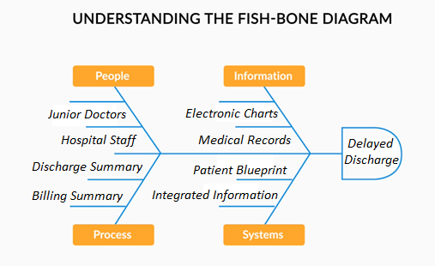

Fish-Bone Diagram

As you can see, the delayed discharge is happening due to multiple factors.

**People** like consultants, medical officers, GDA, nurse-incharge and pharmacist are not completing their tasks on time, as expected. The patient’s inability to pay the bill may also be considered in this case.

**Processes** like preparing the discharge summary or updating the bills and creating a billing summary on time are not followed.

On the **information** front, the activity sheets and reports of the patients are not updated by the nurse in charge and the MO. Due to all this, the **system** of preparing a patient blueprint through the hospital management information system (HMIS) and sharing information with other departments like pharmacy or billing is getting affected. Some of the issues may also include slow or obsolete HMIS, which may cause further delays in the process.

You may add many more such issues under these four buckets to plan the problem resolution accordingly. In the next session, you will learn how to analyse the various solutions for a problem.

Let us summarise your learnings from this session in the next segment.

**Analysing Solutions: Hospital Discharge Process**

Let's say you have identified a set of solutions for the various bottlenecks you are facing in the discharge process.

* You can plan to integrate the entire hospital MIS system more seamlessly to ensure that delays from the pharmacy department during return of medicines can be minimised. You plan to provide an integrated platform for the GDA to enter the medicines that would be returned, and the pharmacy staff validating the returns once received on the platform. This would automatically update the patient's bill reducing the number of back and forth conversations.
* You can request the various stakeholders involved in the patient's care to update the patient bill daily, so that the process becomes less cumbersome during discharge.
* You can plan to recruit additional staff wherever the delay is caused by shortage of staff. Additionally, if the issue is with regards to adherence to the assigned responsibilities, a biometric attendance system can be introduced to monitor the staff in a better way.  You can even consider daily attendance review meetings to scrutinise the staff shortage issue.
* For insurance-based cases, you may include a pre-authorisation step in the case of non-emergency cases of admission. Based on the inputs from the patient and the doctor, the billing desk can send an estimate of the time of discharge and the amount to be released by the insurer. This can reduce the time taken during the discharge process for every step of the process.
* Lastly, the discharge system can be completely integrated through technology. You can think of including acknowledgements at each step so that the time taken to complete each step can be ascertained correctly.

Now, you may want to think about prioritising these solutions based on a few hard constraints. These constraints can be qualitative or quantitative. Based on these constraints, you can eliminate the solutions that do not seem viable to you at all.

For instance, from a qualitative perspective, having a daily attendance review meeting to discuss tracking and monitoring of every employee may be cumbersome, and may not be sustainable in the long run. From a quantitative perspective, you can think about using the cost of implementation as a constraint. Hence, if there are some wasteful steps that you have identified, instead of automating the step (which may drive up the cost further), you can think of eliminating the step entirely in order to save costs. 

You can also look to prioritise your solutions further based on its importance and the ease with which the solution can be implemented. This can be done through a 2X2 Prioritisation Matrix. As an example, let’s try to add some of the possible solutions to speed up the insurance claims process on this matrix.

* **Regular patient file updates**
* **Including a pre-authorisation step in the claims process:**A pre-authorisation usually means an initial amount has been sanctioned by the insurer along with an acknowledgement that the claim will be paid based on the final invoice received from the hospital. In non-emergency cases, by ensuring pre-authorisation forms are filled out in a timely manner by the patient as well as the treating physician, the billing department can send an estimate of the bill to the insurer. Due to this, on the day of the discharge, the process-related bottlenecks in this area would reduce.
* **Tracking claim denials:**Some of the common reasons for claim denials include mistakes in patient’s details, insufficient documents, and errors in information and medical coding. So, if you track your denials regularly, you will be able to see the gaps in your processes more clearly. You can then rectify them right away and improve claim approval rates.
* **Employee training programs:**Dealing with different insurance companies is no easy feat. Each one has its own set of protocols to be followed while filing for the claims. Upskilling your staff will not only equip them with improved knowledge about these protocols but also make them efficient at handling them. Simply put, your claims processes will speed up. From an organisational standpoint, this is a small investment that will eventually reap benefits in the long run.
* **Automating repetitive tasks:**Billing functions such as filing individual claims, assigning the right medical billing codes and creating as well as deploying payment reminders are repetitive tasks that can be easily automated. Doing this will liberate your staff from mundane billing tasks and help them to focus on better patient care.
* **Reviewing delayed claims:** You can dedicate one staff member just to follow up on claims that have not been paid on time. By doing so, you will know exactly why the payments are delayed. It could be a billing error or even a simple miscommunication with the insurer or patient. Once your staff zeroes in on the problem, your reimbursement can be claimed.
* **Disputing denied claims:**There are times when claims are denied despite providing accurate details. To ensure that you do not lose out on revenue, follow up and be ready to negotiate the claim with the insurer. Remember to keep all the details of your claim handy while doing so.
* **Integrate the billing process from the internal hospital IT system with the insurer’s system so that approvals can also be automated through one-step authentication from each stakeholder.**This will ensure that delays caused due to intermediate steps of scanning a bill and manual scrutiny by the TPA can be automated through an integrated claims processing system between the hospital and the insurer.
* **Hire a TPA officer/insurance officer:** Hiring a TPA officer or an insurance officer to also manage your claims can streamline your business’s billing process without any stress to you. These professionals are trained in filing claims of all types and optimizing business revenue. They can be the coordinators between the TPAs and the hospital.

**Try to place these solutions in a 2X2 matrix in order to prioritise your solution further.**

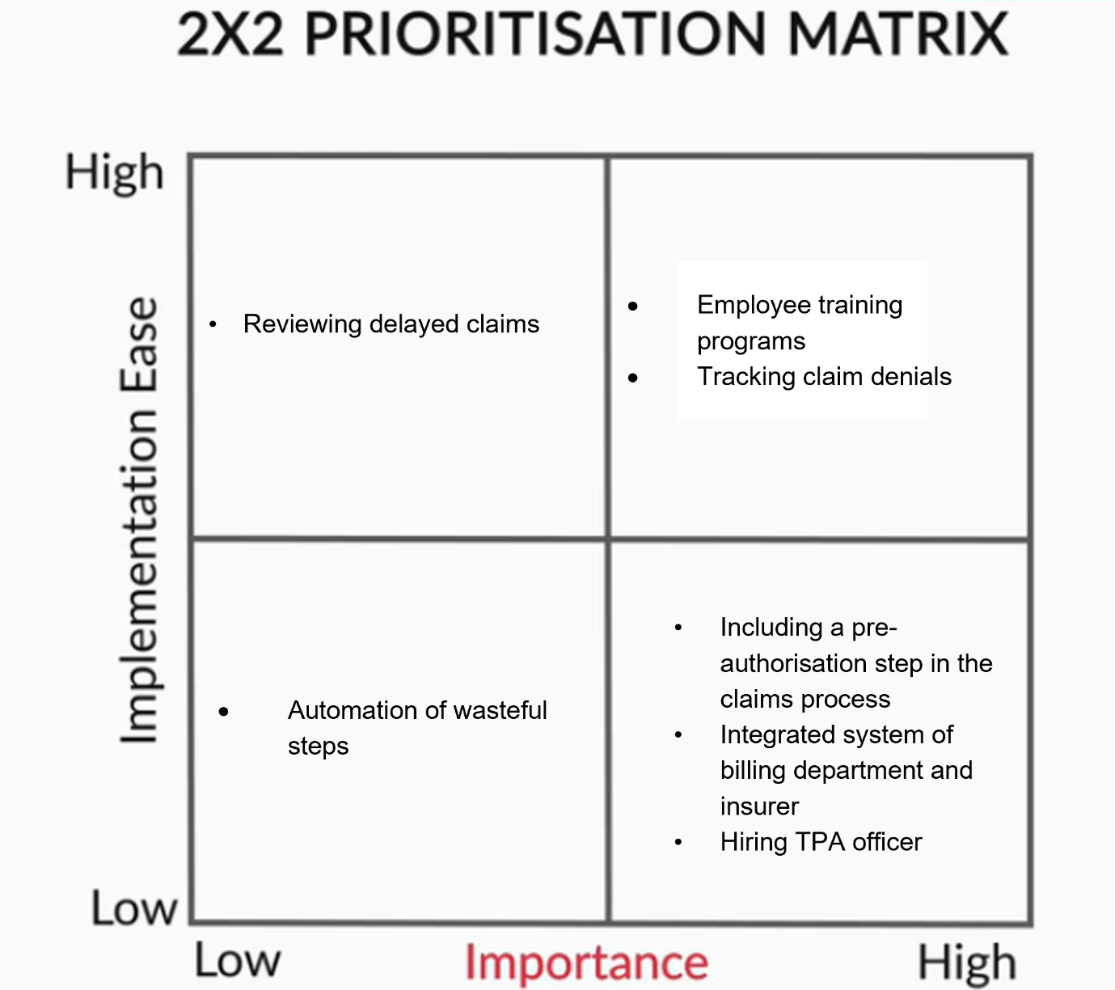

Prioritisation Matrix

**Implications**

You can now think about the implications that these solutions would have on people, systems and processes. Let’s list down a few implications that some of these solutions might have on people.

**Employee training programs:**Staff would need to keep themselves updated and actively participate in the training programs to be able to improve coordination and process clarity.

**Reviewing delayed claims:** Having a dedicated person for this task would mean that some of the responsibilities would need to be reconsidered, and the manpower planning will need to be reassessed.

**Introducing a TPA officer role:** When introducing a new role, you would need to consult various people in the organisation and you would also need to discuss the scope and growth of this role in the organisation. Additionally, benchmarking compensation, conducting trainings and any team-related queries would also become important to consider in this case.

Now, let’s move on to the process-based implications. Based on the analysis of denied claims, some steps would need to be reassessed, and you would also need to rethink the workflow in case a step needs to be eliminated in the discharge process. Additionally, bringing a medical billing management services firm onboard would also demand some process-based changes in the existing workflow.

From a systems perspective, integrating the billing system with the insurer’s system would need some level of restructuring of the existing systems in order to ideate on these new features. Adding a pre-authorisation step that runs seamlessly through all the systems may also require some significant system overhauls.

Now that you have learnt about analysing the solutions, in the next session, you will learn about implementing solutions.

# Implementing Solutions: Hospital Discharge Process

Let’s take a look at how some of the solutions discussed in the previous session can be implemented on a pilot basis, so that you can obtain quick results and modify the process, if needed.

1. Starting with the training program for the employees, you may start with a few employees and observe if the program helps improve their awareness of the process, and readiness in successfully carrying out the discharge process with ease.
2. You can also try out the medical bill management services on a trial basis to check how feasible and effective the solution is, and compare it with an in-house option of employee training and process improvement.

While testing out some of these solutions, you may also need to assign a resource to analyse claim denials and delays, and ascertain patterns that can help in improving some of the proposed solutions further.

You would need to ensure you follow the four-step approach (framing the problem, analysing the problem, analysing the solution and implementing the solution) to each of the pain points that you have identified in the process. This would help you in making an informed decision after analysing and evaluating the various solution options that you ideate.

Additionally, you would need to track a few key metrics consistently to measure and compare your solutions.

Some of the metrics that you can consider are:

* Measure different parts of the discharge process individually and overall as well (to know which parts are most time-consuming)
  + Doctor’s order for discharge to patient folder being sent to billing
  + Processing of patient’s final bill to the time the discharge slip is issued to the patient
  + For insurance patients, measure the turnaround time from applying for a claim and obtaining TPA approval

## ****The Way Forward****

In order to make the entire discharge process more streamlined and monitor the various steps in the process, you can consider having a dedicated 'discharge executive'. This person would track and monitor the entire process and would be accountable for the entire discharge process. This executive would be dedicated to ensuring that there is clear communication and coordination between the different departments. The executive would also ensure that people, processes, information and systems and working in tandem to address the root causes of each of the issues faced at each level.

In the next segment, you will go through the summary of this module.